**Test Your Understanding**

**Question**: Post the June journal entries to the ledgers.

**Question Input:**

|  |  |  |  |
| --- | --- | --- | --- |
| **Date** | **Account** | **Debit** | **Credit** |
| 6/1 | Cash | 10,000 |  |
|  | Common Stock |  | 10,000 |
| 6/1 | Miscellaneous Expense | 50 |  |
|  | Cash |  | 50 |
| 6/2 | Supplies Expense | 150 |  |
|  | Accounts Payable |  | 150 |
| 6/5 | Cash | 200 |  |
|  | Fees Earned |  | 200 |
| 6/6 | Accounts Receivable | 250 |  |
|  | Fees Earned |  | 250 |
| 6/8 | Accounts Payable | 150 |  |
|  | Cash |  | 150 |
| 6/9 | Accounts Receivable | 450 |  |
|  | Fees Earned |  | 450 |
| 6/10 | Supplies Expense | 40 |  |
|  | Accounts Payable |  | 40 |
| 6/13 | Salary Expense | 600 |  |
|  | Cash |  | 600 |
| 6/16 | Cash | 500 |  |
|  | Fees Earned |  | 500 |
| 6/17 | Supplies Expense | 30 |  |
|  | Accounts Payable |  | 30 |
| 6/20 | Cash | 250 |  |
|  | Accounts Receivable |  | 250 |
| 6/21 | Accounts Payable | 40 |  |
|  | Cash |  | 40 |
| 6/24 | Accounts Receivable | 750 |  |
|  | Fees Earned |  | 750 |
| 6/25 | Truck Expense | 175 |  |
|  | Cash |  | 175 |
| 6/27 | Salary Expense | 600 |  |
|  | Cash |  | 600 |
| 6/29 | Accounts Receivable | 1,600 |  |
|  | Fees Earned |  | 1,600 |
| 6/30 | Cash Dividends | 700 |  |
|  | Cash |  | 700 |
|  |  |  |  |

**Student Answer Sheet:**

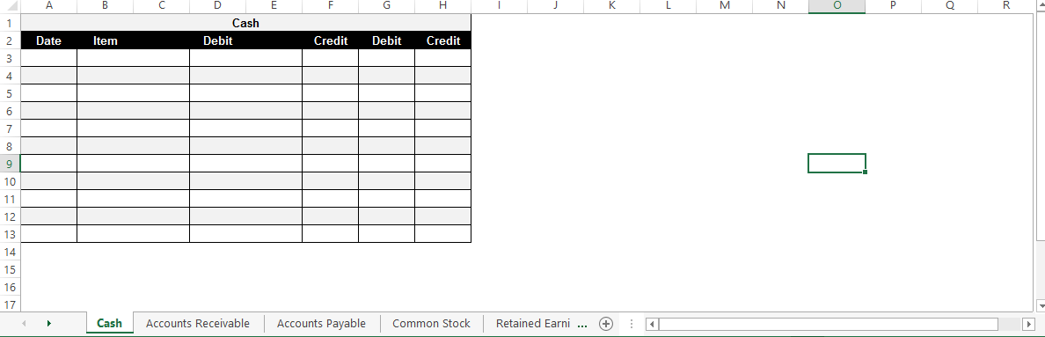

*Sample Student Sheet:* 